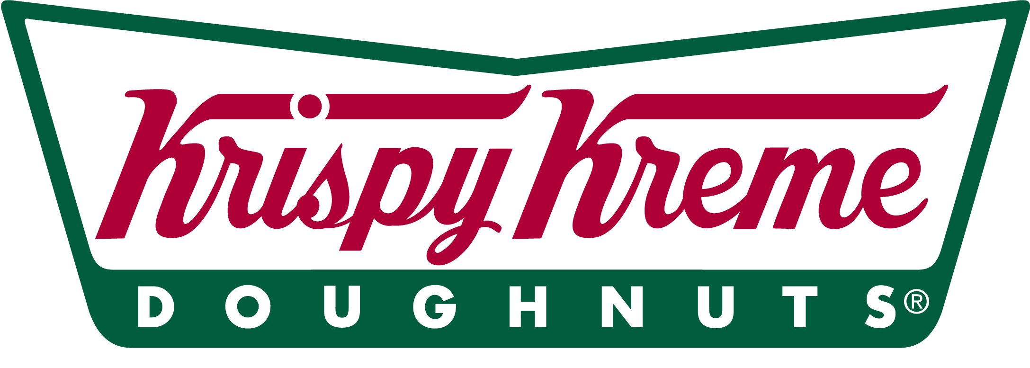
Amazing Glazed, L.L.C.
511 Rodi Road
Penn Hills, Pa 15235

GID
808 Little Deer Creek Valley Rd
Russellton, PA 15076

Dear Shawn Gminder:

I want to formally thank you and your staff at Get It Done Mailing Service, for doing exactly what your name says, You Get It Done. You have saved Krispy Kreme doughnuts and myself valuable time and money through your mailing services. Not to mention, you have lifted the enormous burden from me to cut costs and to get our mailings out in a timely fashion. You and your staff have been fast and efficient in meeting my needs and the needs of Krispy Kreme doughnuts.

Krispy Kreme’s philosophy believes in a traditional, “grass-roots” approach of marketing. Without an advertising budget, getting the word out about our specials, promotions, and events is quite a task. I used to spend a small fortune to do in house mailings to our customers. With GID Mailing Service, the mailings we do now are of no comparison. The cost is considerably less expensive. The mailings are also targeted directly to the homes and businesses of our demographic, and are of a much higher quality. I couldn’t be more pleased with the success of using the GID Mailing Service to announce all of our newest promotions and events.

Shawn, thank you for providing Krispy Kreme doughnuts and myself with outstanding service. I look forward to working with you again in the near future.

Warmest Regards,

Amber Kozler

Amber Kozler
Director of Marketing
Krispy Kreme doughnuts

